**Layer two (Data Link Layer) and Layer 3(Network Layer)devices**

**There are** billions of computer interconnected with computer network and are located over the world. So in order to ensure national and worldwide data communication, systems must follow a standard which is compatible to communicate with each other.

**In OSI (**open system interconnection model) is a conceptual model that characterize and standardizes the communication function of telecommunication or computing system.

In OSI (Open system interconnection) we have seven layer each layer has its own functionality

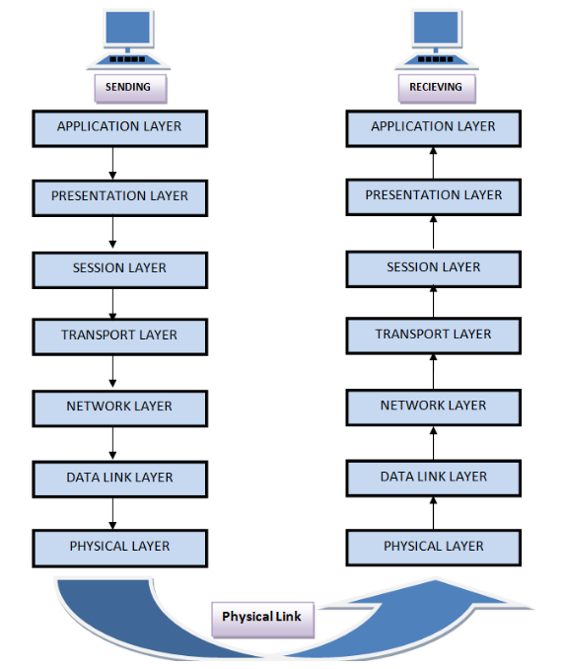

Layer one (Physical Layer) this layer performs the following functions

* It is lowest layer of OSI(open system interconnection model)
* It activates , deactivates , maintains the physical connection
* It converts the digital/analog data into electrical or optical signals
* Data Encoding is also done at this Layer

Layer two (Data link Layer) has the following responsibilities

* Data Link layer synchronize the information which is to be transmitted over the physical layer.
* The main function of this layer is to make sure data transfer is error free from one node to another node.
* Switches works at this layer and forwarding decision is made based on MAC (media access control) table.
* This layer is further divided into two sub-layer

1. LLC(logic Link control)
2. Media Access control(MAC)

* Transmitting and receiving data sequentially is managed by this layer

**Logical Link control (LLC):** logical link control refers to the functions required by establishment and control of logical links between local devices on network. .

**Media Access control (MAC):** This refers to the procedure used by devices to control access to network.it is responsible for framing and de framing and collision detection.

In ipv6 enabled network we also use CDP (cisco discovery protocol) to check the layer two connectivity.

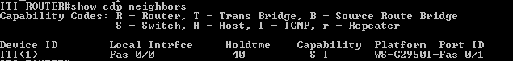

Although CDP(cisco discovery protocol) at data link layer but it also gives information about IP(internet protocol) address of connected devices which works at layer three(network layer).

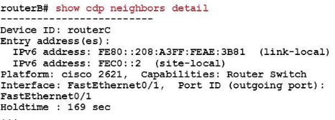

**Layer 3: Network Layer**

The network layer is responsible for the followings

* It routes the signal through different channels from one to other.
* If there are multiple ways to reach the destination it the job the layer three to decide to choose which path should be taken to reach the destination
* It devices the outgoing messages into packets and assembles the incoming messages into packets for g higher levels.
* 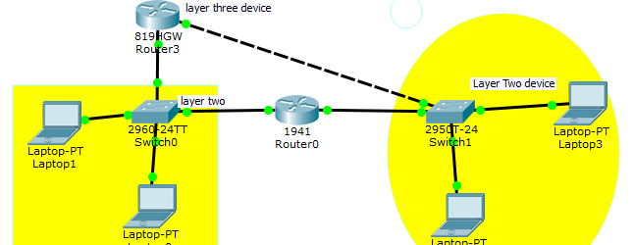Routing is done at layer three (network Layer) in order to send packet from one network to another network Router must be there. It decides where to forward data based on routing table.
* On the router we have to configure any routing protocol that will enable router to make forwarding decision. There are two ways to configure router to use routing to make forwarding decision

(1) Static route

(2) Dynamic Route

In Static routing Paths are pre-computed by host and are loaded into routing table. The paths are fixed packets will be following that particular path. Static route is good when

* Network size is small
* Traffic load does not change variably
* Network topology is fixed and there is no need for router to perform any algorithm to determine the path.
* In dynamic routing each node computes the best path by communicating with its neighbor .Each node continuously learn the state of network by communicating with its neighbor. Path are not predefined they are determined by the router where to send the data. The example of Routing protocol includes RIP (Routing information protocol), OSPF (Open shortest path first) in IPV4. In IPv6 we have RIpng (RIP next generation) and OSPFV3 (open shortest path first version three).

**Configuring Static route between Routers**

Static route is form of routing that occurs when router uses a manually-configured routing entry rather than information from dynamic routing protocol.

(1) BY default port are shut down and in order to make the port open enter the command in configuration mode (“interface interfacee number”) and then put “no shut”.

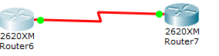



After that have to use (**“ip route net hop address subnet mask Ip address of next Router ingoing interface”)**

**Enter the following command**



**This command will enable the Router A to redirect all traffic to (172.16.3.2) who is destined for (172.16.1.0 ) network.**

**If you want to configure Static route in IPV6 enable network same command will be used only the IP addresses will be changed .**

**Another simple way to configure static route is (“ip route next hop ip address subnet mask , outgoing interface number of Router A).**



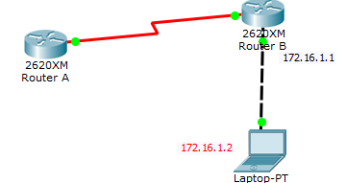

**And if you want to see the routing table enter the command “show ip route” it will list down the routing table that router is going to use in order to make forwarding decisions.**

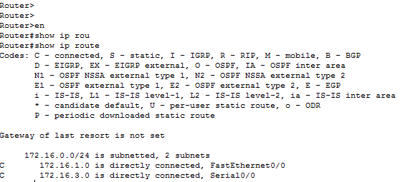

In order to determine which path is being followed by packets to reach the destination use the “tracert” command in window based system and “traceroute” in cisco Devices.

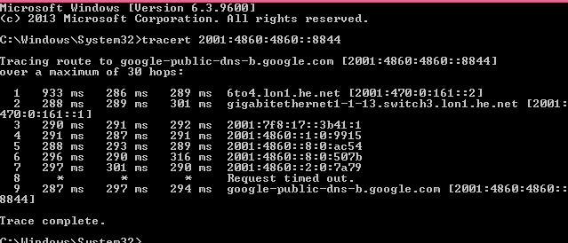

In Linux based system

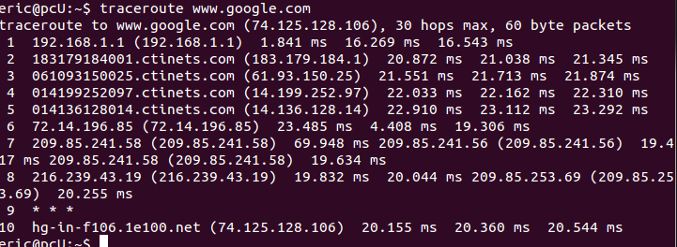

In cisco devices

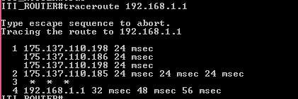

Layer4: Transport layer

The transport layer has the following responsibilities.

* It decides if data transmission should be on parallel path or single path

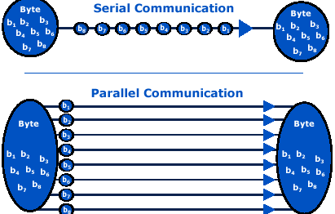

* It receives messages from session layer above it , convert the message into smaller units and passes it to network layer.

Layer 5: Session Layer

* Session Layer manages and synchronize the conversation between two different application
* It is responsible for establishing and teardown of connection

Layer6: Presentation Layer

* Presentation layer takes care that data is sent in such a way that receiver will understand the information (data) and will be able to use the data.
* It performs data compression, data Encryption m data conversion and etc.

Layer 7: Application Layer

* It is the uppermost Layer in OSI( open system interconnection model)
* This layer mainly holds application program to act upon the received and to be sent data

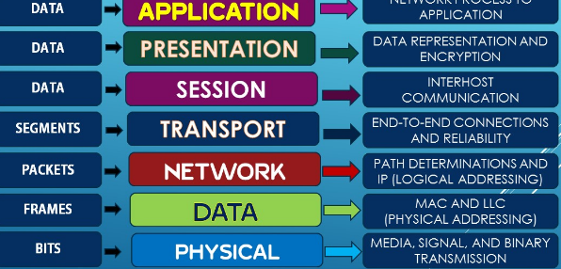

Loop back interface in IPv4 and IPv6

In computing localhost (loopback address) is the address is used to check the connectivity to network interface card. It is used to access the network services that are running on the host via it loopback network interface.

For example Sys log are used to keep track of activities going on inside the network so we can use loop back address on routers to uniquely identify each router, switch instead of IP address.

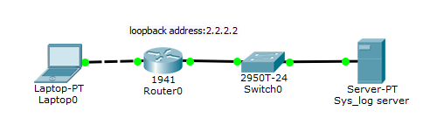

In cisco router and switches we can configure loopback in Ipv4 loop back address is 32 bit long. While in Ipv6 loopback by default is **0000:0000:0000:0000:0000:0001** and can be summarized as **::1.** In cisco router and switches one switch or router can have more than loopback address while for PCs there can be only loopback address that is (127.0.0.1) in IPv4 and in case of Ipv6 it is (::1).

In order to configure loopback address on cisco switch or router follows these basic steps

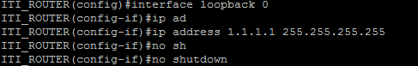

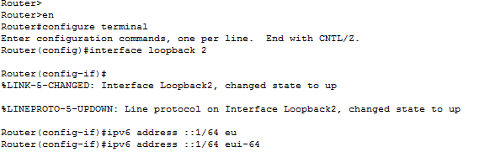

IPv4 (internet protocol version four) network standard reserve the entire 127.0.0.0/8 block for loopback purpose . That means any packet sent to one of these **16,777,214**  addresses (127.0.0.1 through 127.255.255.254) is a looped back. While IPv6 has just a single address **::1.**

Quick Quiz

1. Under what conditions static route is better than Dynamic routing protocol?

Answer: When we are dealing with simple network than static routes are better than Dynamic routes because in static routes there is no need for routers to perform any action in order to determine the path .But for complex and big network it is very difficult to configure static route.

2. Write two types of Dynamic routing protocols?

Answer: The most commonly used routing protocols in IPv4 are RIP (Routing information protocol) , OSPF(open shortest Path first) in ipv6 RIpng(Routing information protocol next generation) and OSP3(open shortest path first version three)

3. At which layer of OSI model encryption, compression is performed?

1. Application
2. Presentation
3. Transport
4. Physical
5. Network

Answer: presentation Layer

4. At which layer of OSI model Segments are used?

1. Transport
2. Network
3. Session
4. Presentation

Answer: Transport Layer

5. Which device makes the forwarding decision based on routing table ?

A. Switch

B. Router

C. Repeater

D. None of above

Answer: the router makes forwarding decisions based on routing tables

6. Host A is communicating with host B what Will be destination IP address when Packets reached at Router A?

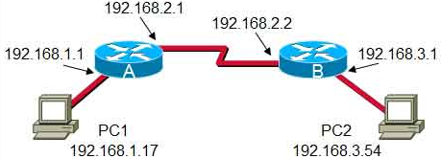

(A) 192.168.3.254

(B) 192.168.3.1

©192.168.2.2

(D) 192.168.2.1

Answer: source and destination IP address never changes during the communication while MAC(media access control) address keep changing when they go through the routers.

(8) Which devices make the forwarding decision based on MAC (media access control) table?

(A) Switch

(B) Routers

© Network interface cards

(D) Repeaters

Answer: Switch works at Layer two(Data link layer ) and they makes forwarding decision based on MAC address table and it can be viewed using the command “show mac-address table” in cisco switches.

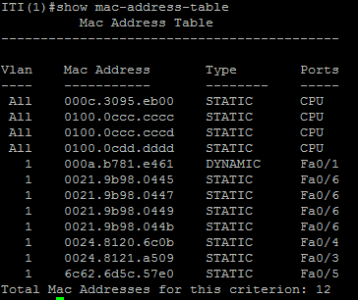

(9) What the function of CDP (cisco discovery protocol)

(A) It is used to check the layer two connectivity

(B) Is used to make remote access to network

© Is used to make secure web communication

(D) None of the above

**Answer: CDP works at Data link layer (Layer 2) and is used to Layer two connectivity.**

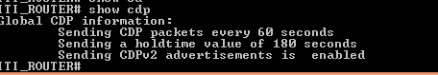

(11) Which command is used to enable IPv6 configuration on cisco devices?

1. *IPV6 unicast-routing*
2. *Show ipv6 interfaces brief*
3. *Show cdp neighbors detail*
4. *Show ipv6 route*

**Answer: IPv6 unicast-routing is a command which is used to enable ipv6 on cisco devices.**

**(12) Write down seven Layers of OSI model?**

**Answer:**

1. **Physical layer**
2. **Data link layer**
3. **Network layer**
4. **Transport Layer**
5. **Session**
6. **Presentation**
7. **Application**

**(13). OSI stand for?**

1. **Open source initiative**
2. **Open system interconnection**
3. **Open system integration**
4. **Optical storage international**